**Experiment Name :- HAlf_Wave_Simple_Dipole**

*Student Name :- Mr.Shibu_Shirsh_Shivam*

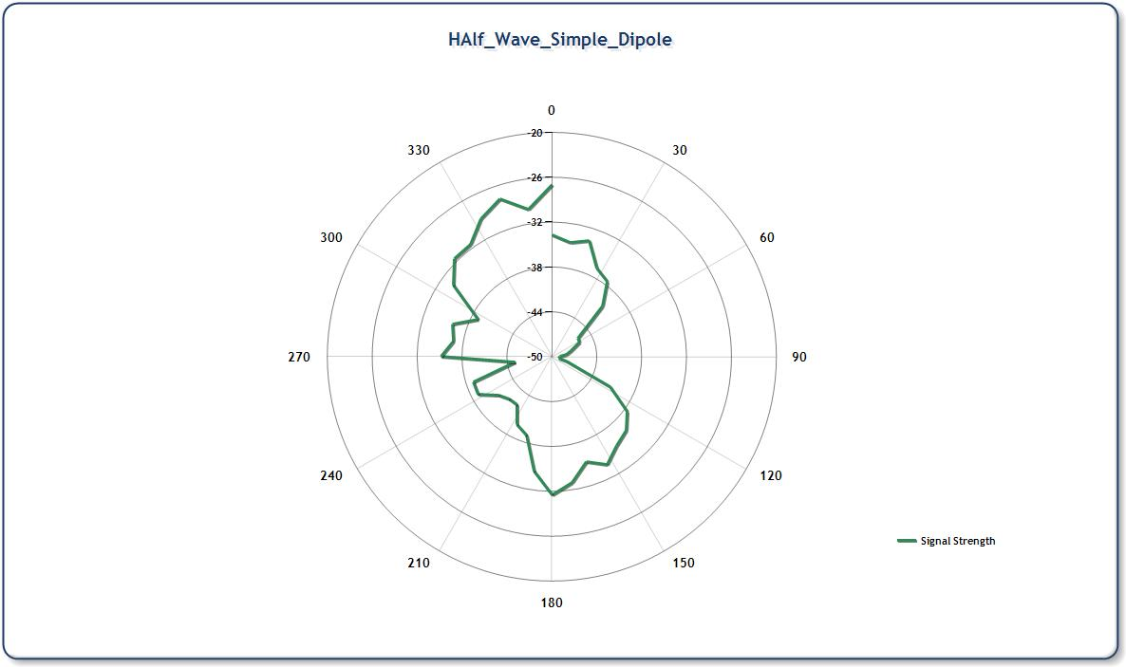

*signature of class teacher*